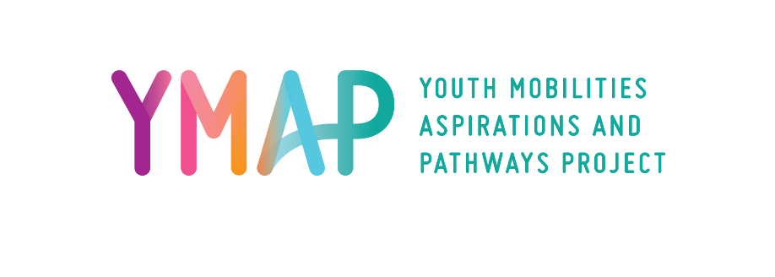

Plain Language Statement
Full Project Title: Understanding the Effects of Transnational Mobility on Youth Transitions
Principal Researchers: Professor Anita Harris, Deakin University
Professor Loretta Baldassar, University of Western Australia
Associate Professor Shanthi Robertson, Western Sydney University

This Plain Language Statement contains information about the research project. Its purpose is to explain to you as openly and clearly as possible all the procedures involved in this project, so that you can make a fully informed decision whether you are going to participate. Please read this Plain Language Statement carefully and feel free to ask questions about any information in the document.

The purpose of this Australian Research Council Discovery Project is to examine transnational mobility amongst young people moving both in and out of Australia in order to understand its effects on their economic opportunities, social and familial ties, capacity for citizenship and transitions to adulthood. It charts how youth manage mobility and develop economic, social and civic benefits and manage challenges.

This research project will take place over a five-year period in total and 2000 participants will take part. You are invited to participate because we are interested in hearing from young people who are either Australian-born or Australia-bound and aged 18-30. Half of the participants will be citizens/permanent residents of Australia who are travelling ‘out’ and have left Australia for 6+ months, and half will be ‘incoming’ i.e. citizens/permanent residents from other countries who are travelling ‘in’ and have entered Australia for 6+ months.

We hope to survey 2000 young people (three times, over the course of the project). We’re also going to ask a small subset of young people to take part in a series of in-depth interviews (three times, over the course of the project) and/or a series of tasks using a Mobile Ethnography App called Indeemo (three times, over the course of the project). These tasks will include posting in-the-moment videos, screen recordings, photos and notes.

We will request participant consent for each component of the research separately and taking part in one component does not oblige commitment to all three components of data collection (survey/interviews/series of tasks using app).

Possible benefits of taking part in the study include the opportunity to reflect on and develop insight into your own mobility. More broadly, the research will assist in understanding the types, motivations, conditions and outcomes of transnational mobility amongst a diverse set of young people in order to understand its actual effects on their economic, social and civic wellbeing, as well as on their community and familial ties.

Participation in this research project is entirely voluntary and you are free to withdraw by opting out without being penalised or disadvantaged in any way. To do this you may contact the researchers at any time prior to the publication of findings. If you opt out, any data you have already supplied will be destroyed. The only exception to this will be any non-identifiable data that cannot be extracted from the database but can never be linked to you.

Your participation may involve the disclosure of sensitive personal information; for example, issues related to cultural identity, belonging and life plans and hopes will be explored. While it is highly unlikely, there is a potential for you to experience some discomfort or distress when responding to project questions. If this occurs, please contact Lifeline (a 24-hour counselling service) on 13 11 14 if you are in Australia. If you are outside Australia, please contact Befrienders Worldwide (they assist with finding an emotional support service in your country) https://www.befrienders.org/. Please also feel free to contact the research team directly and we will recommend an appropriate local service (ymap@deakin.edu.au).

All information gathered from participants will be kept securely on university networked and password protected cloud storage. Only the research team directly linked with the project will have access to the raw data during the project. All participants will be assigned a pseudonym and data used in reports or published findings will not contain names or identifying characteristics. Non-identifiable statistical data from the surveys may be made available to other researchers via university or government open data repositories at the completion of the project, in accordance with institutional open data policies. All the information you supply will be stored securely and it will be de-identified before it is made to available to any other researcher.

Research findings will be published in reports and academic journals and books. No names or identifying characteristics will be used in any published findings. Updates, progress reports and results of the study can be found on the project website (https://www.ymapproject.org/) for you to access any time.

Research Team:

Professor Anita Harris

Alfred Deakin Institute for Citizenship and Globalisation

Faculty of Arts & Education
Deakin University
anita.harris@deakin.edu.au

Professor Loretta Baldassar

Anthropology and Sociology
School of Social Sciences
University of Western Australia
loretta.baldassar@uwa.edu.au

Associate Professor Shanthi Robertson
Institute for Culture and Society
Western Sydney University
s.robertson@westernsydney.edu.au

If you have any complaints about any aspect of the project, the way it is being conducted or any questions about your rights as a research participant, then you may contact:

The Manager, Integrity, Ethics and Biosafety,
Deakin University,
221 Burwood Highway, Burwood Victoria 3125,

Telephone: 9251 7129, research-ethics@deakin.edu.au

Please quote project number 2017-315.

